Step 1: Create a new channel on slack workspace by clicking on plus sign on left side below

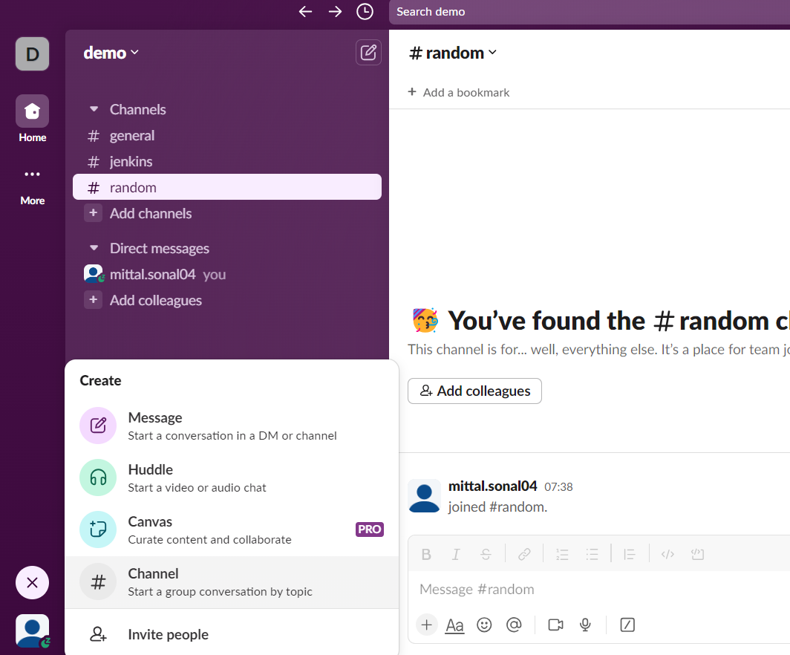

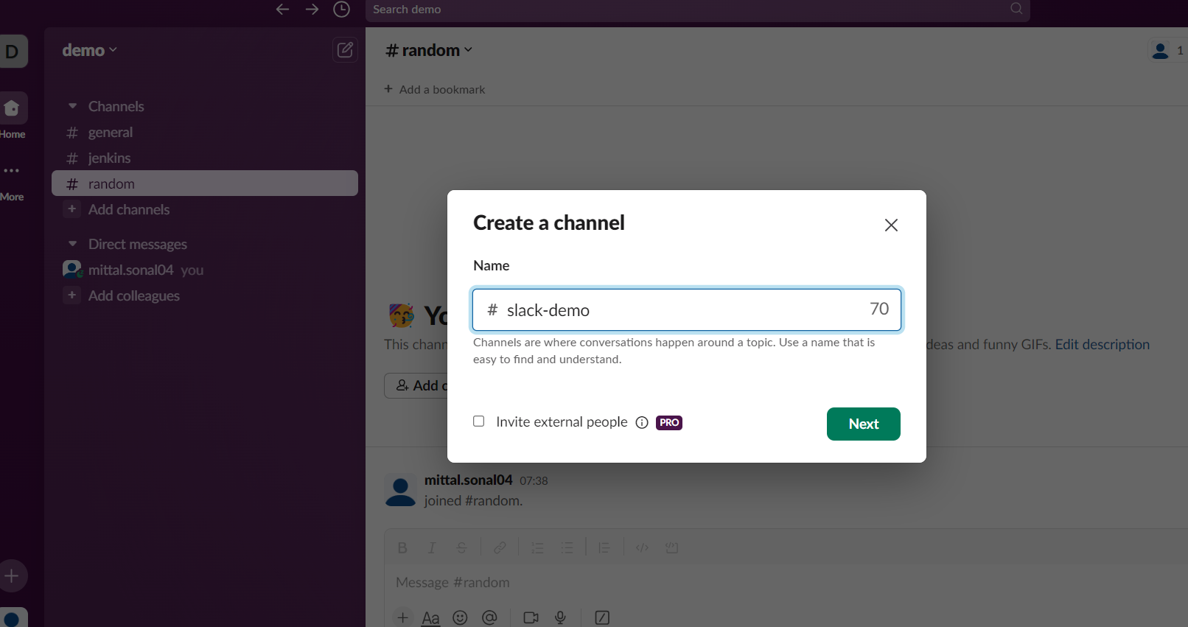

Click on next button and select public

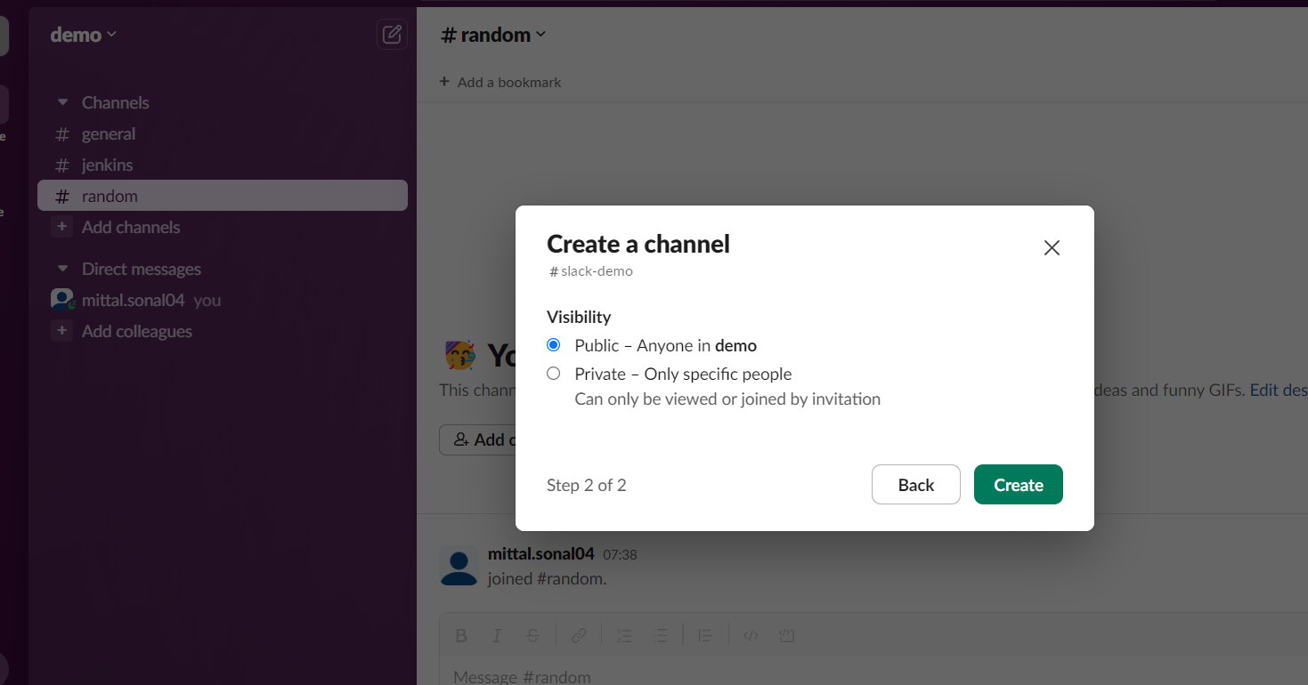

Click on create

Click on skip for now

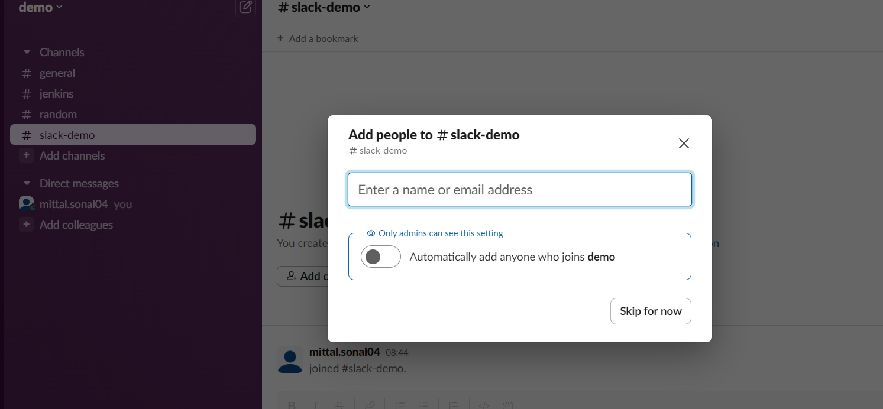

You will see the demo

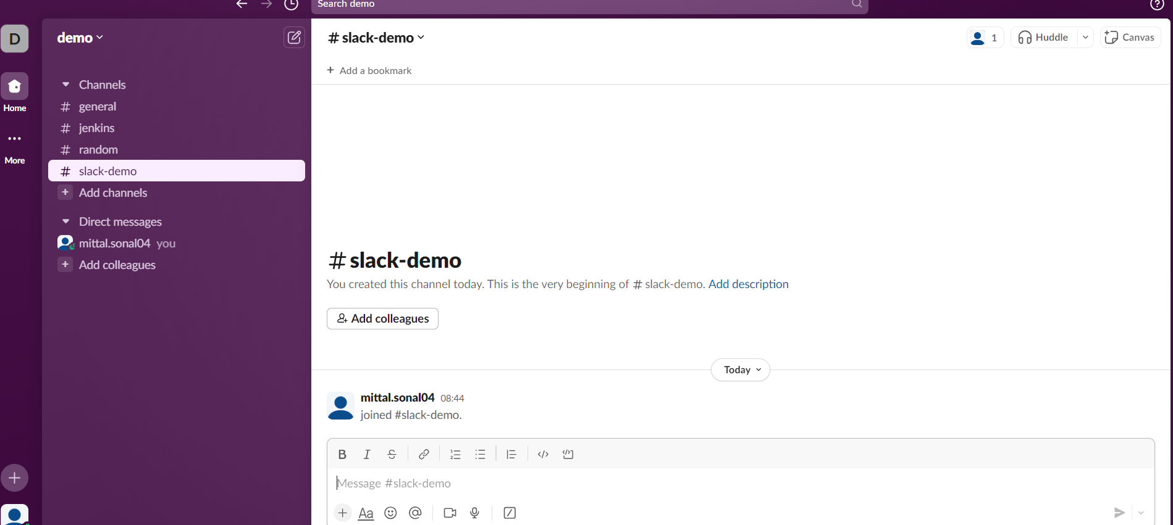

Integrate with Jenkins app on Slack

=======================

Click on channel name slack demo 🡪 on top right side



Click on integration tab

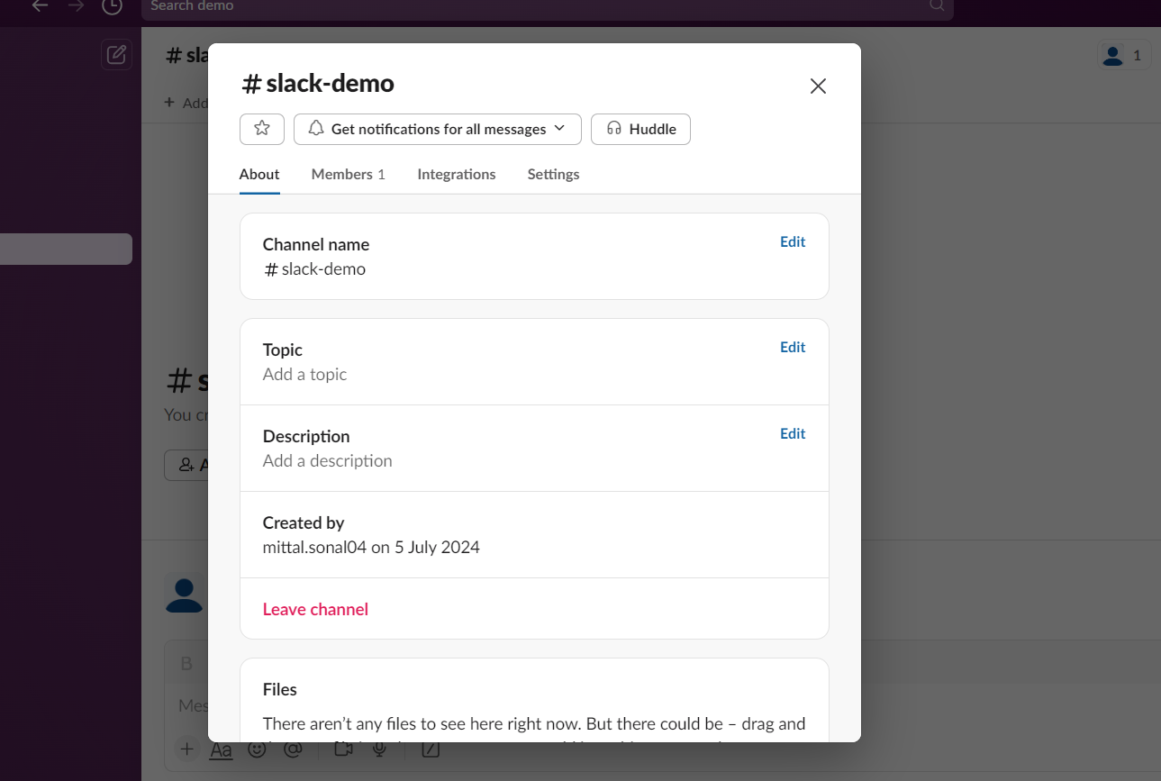

Click on Add an app

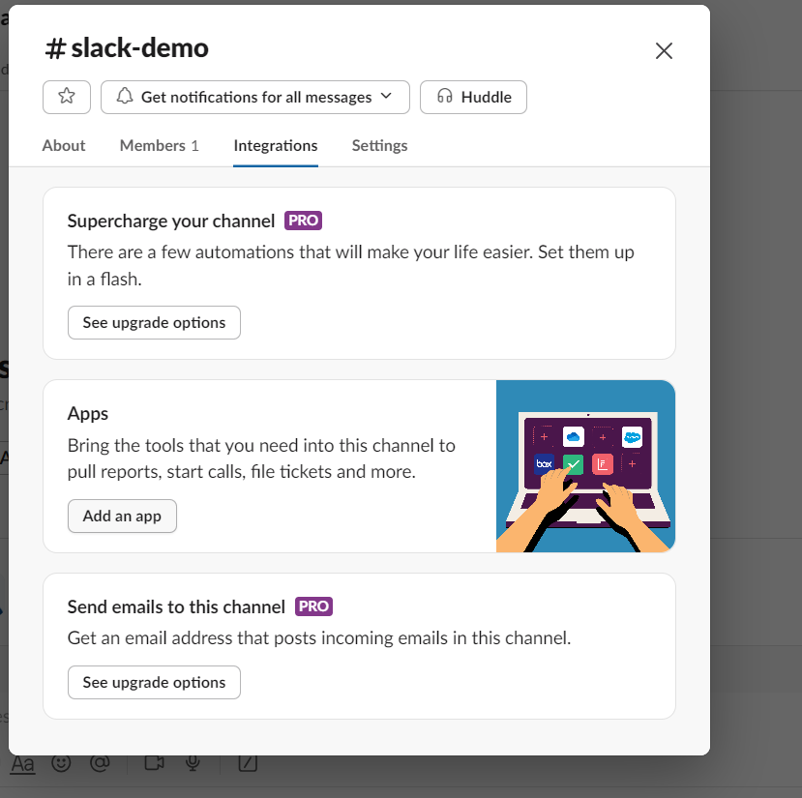

You wills ee app directory, search for Jenkins

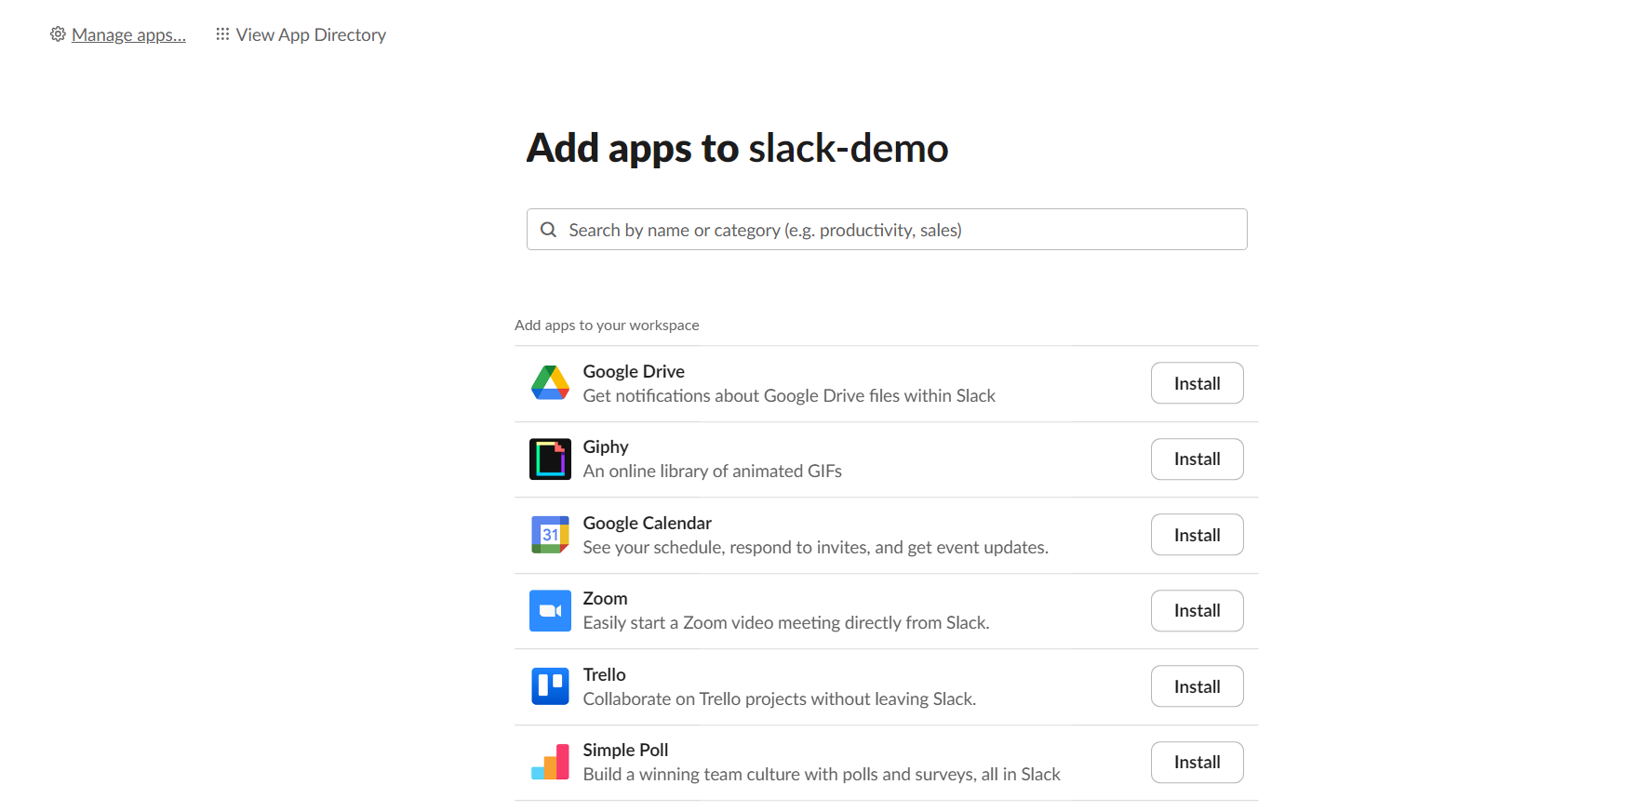

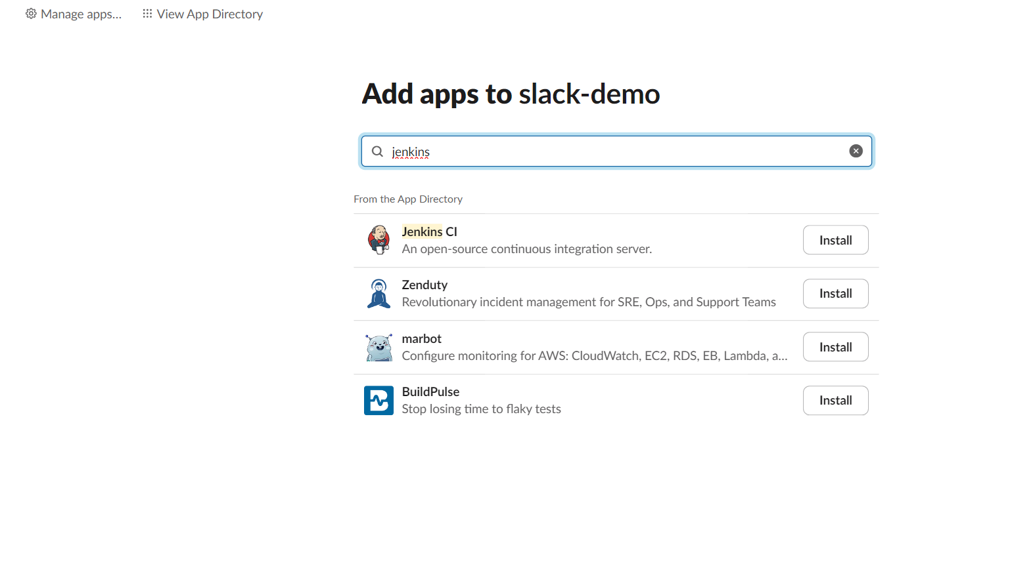

Click on install

Click on Add to install

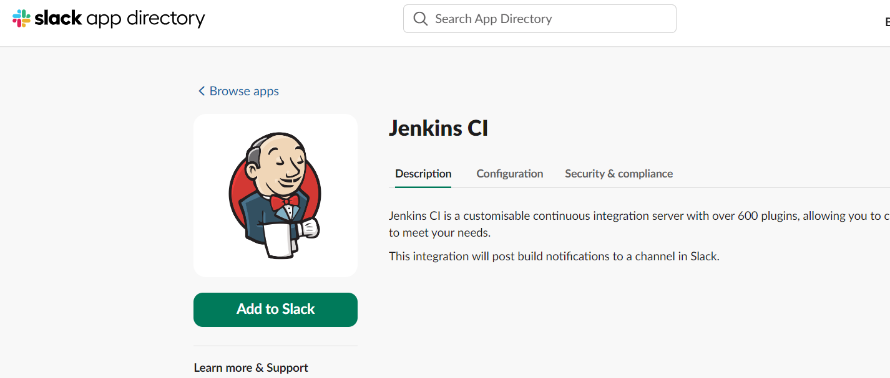

Select your channel form the drop down

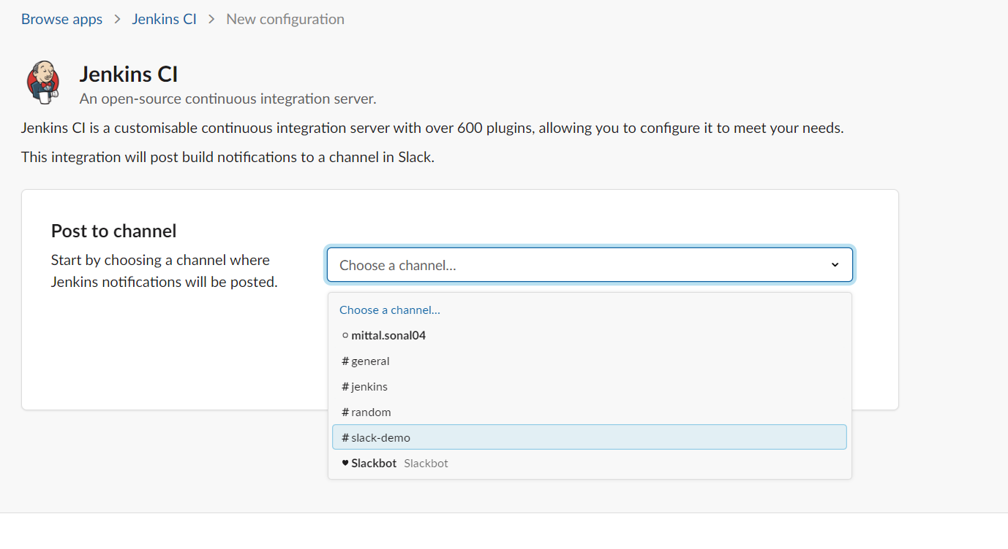

Click on Add CI integration button

You will be on Jenkins configuration page

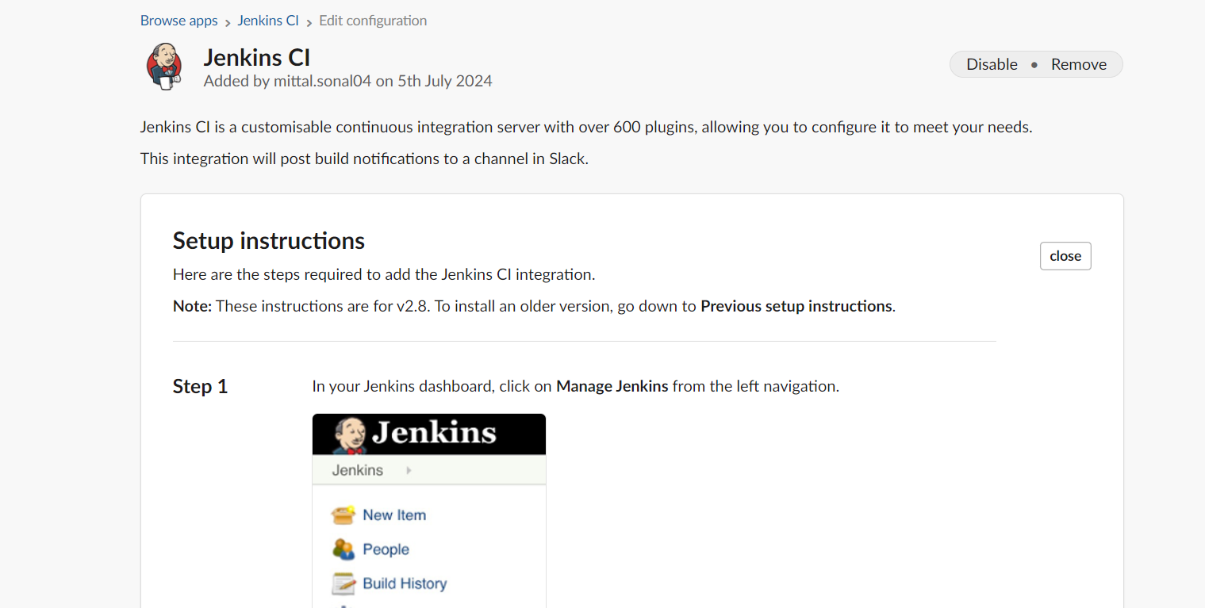

Scroll down to step -3 , you will see sub domain and token details.. we need them to be used in Jenkins. Copy them and keep it

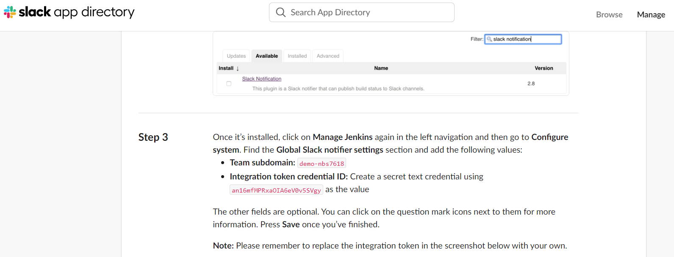

Go to Jenkins now and download slack plugin

Go to manage Jenkins 🡪 plugin manager 🡪Available plugins 🡪 search for slack notification plugin

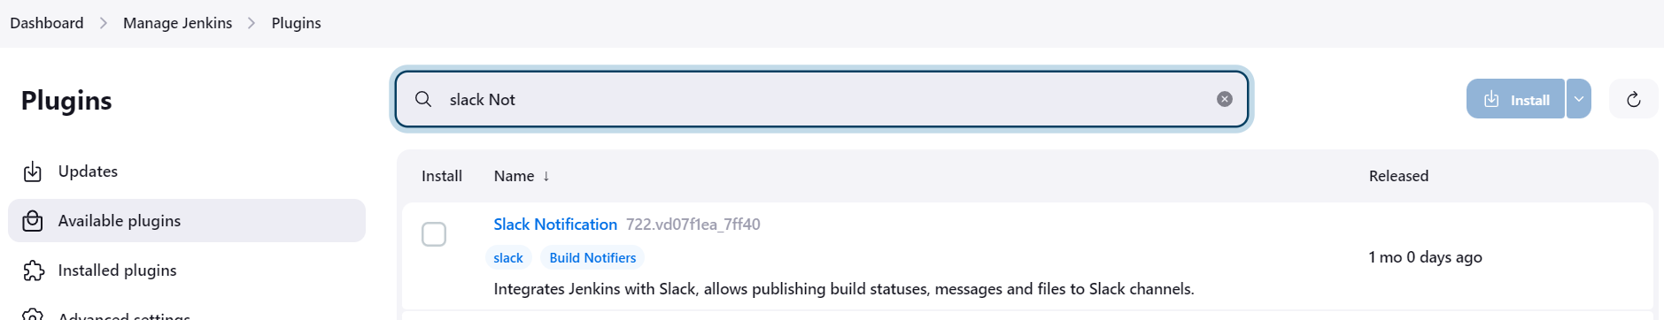

Click and install it

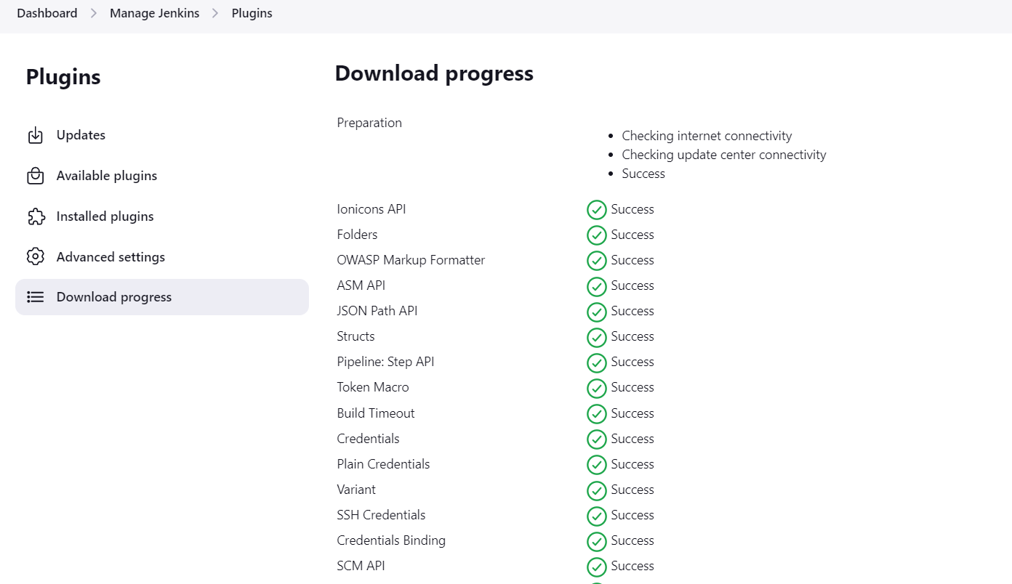

We will now configure Jenkins to communicate with slack

Manage Jenkins 🡪 System 🡪 scroll down to see Slack configurations:

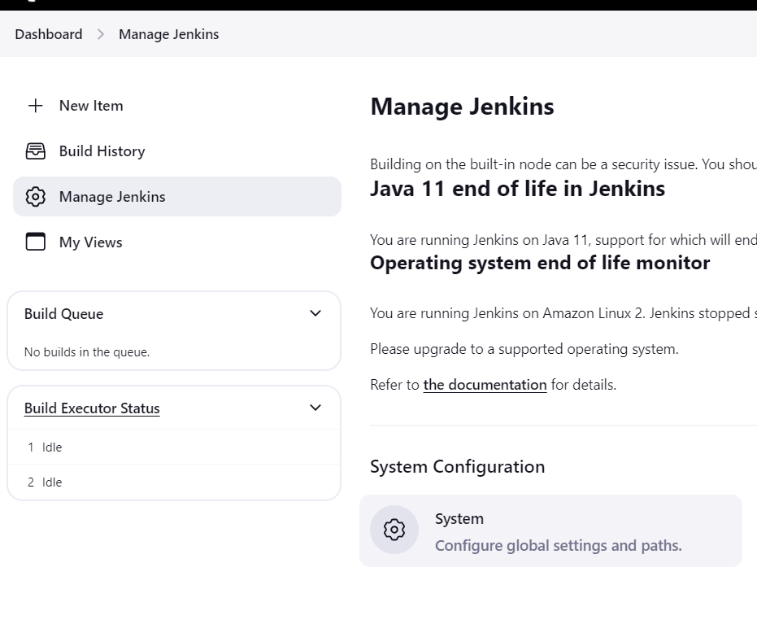

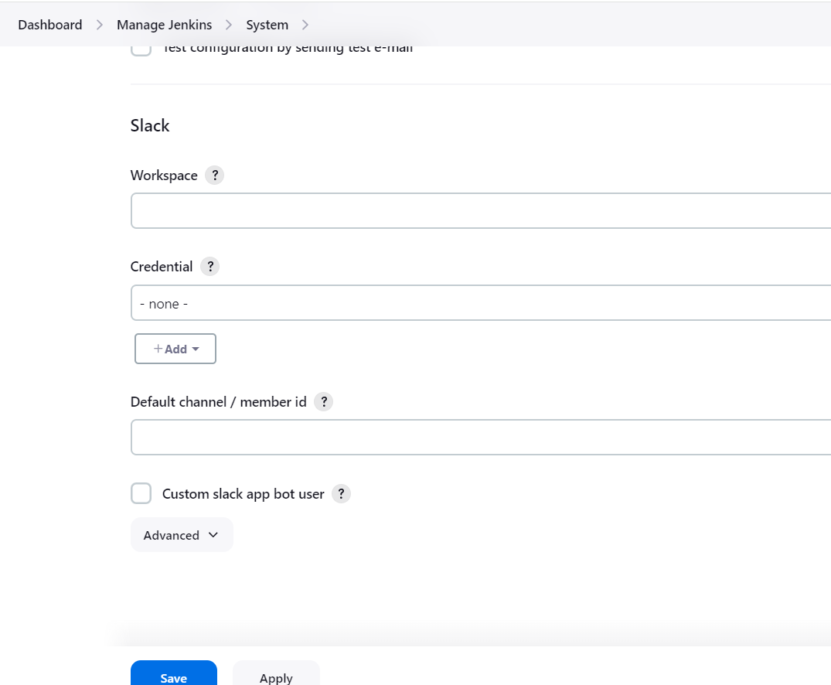

In workspace give the subdomain value we copied from slack jenkisn CI integration page

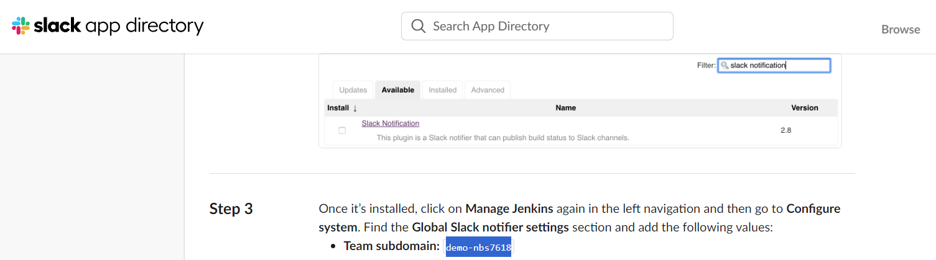

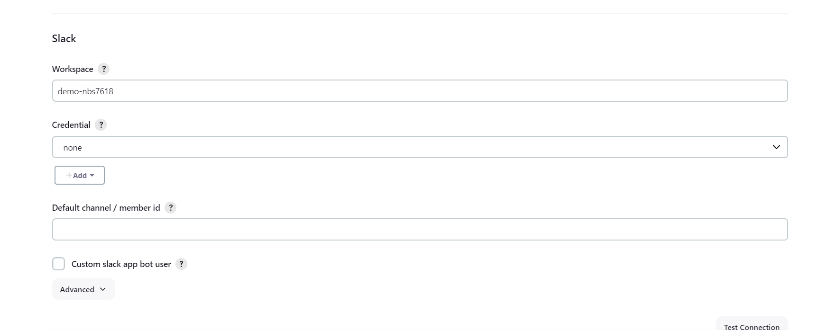

Create Jenkisn credentials as secret text to enter the token for slack

The slack token is available at slack- Jenkins CI page

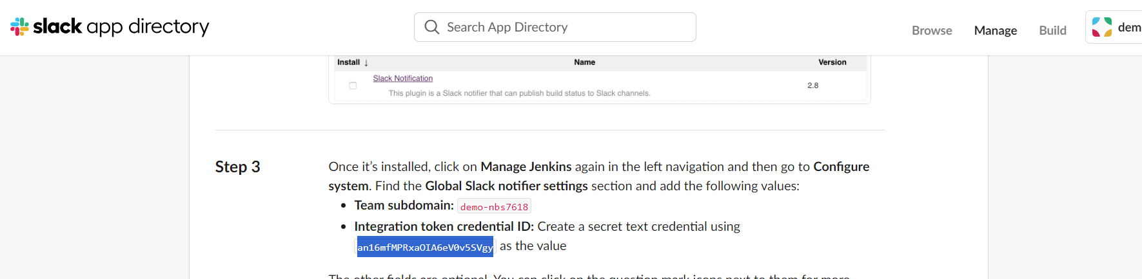

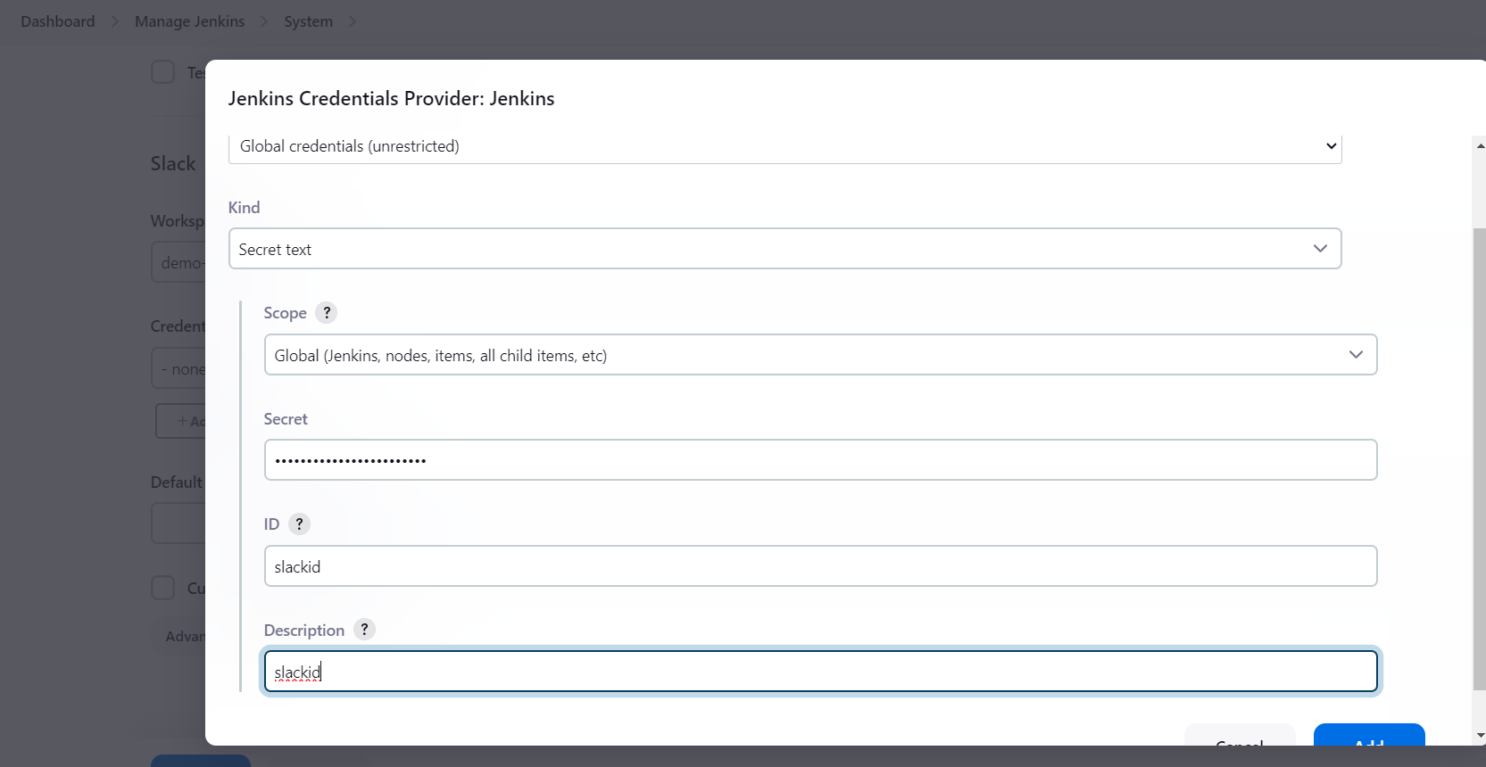

Save the credentials and select it form the drop down

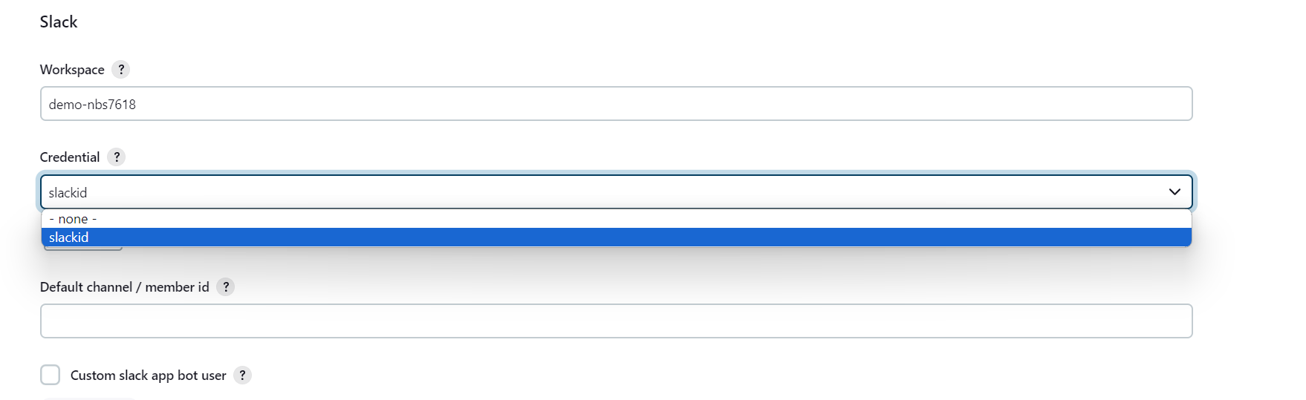

And give the slack channel name

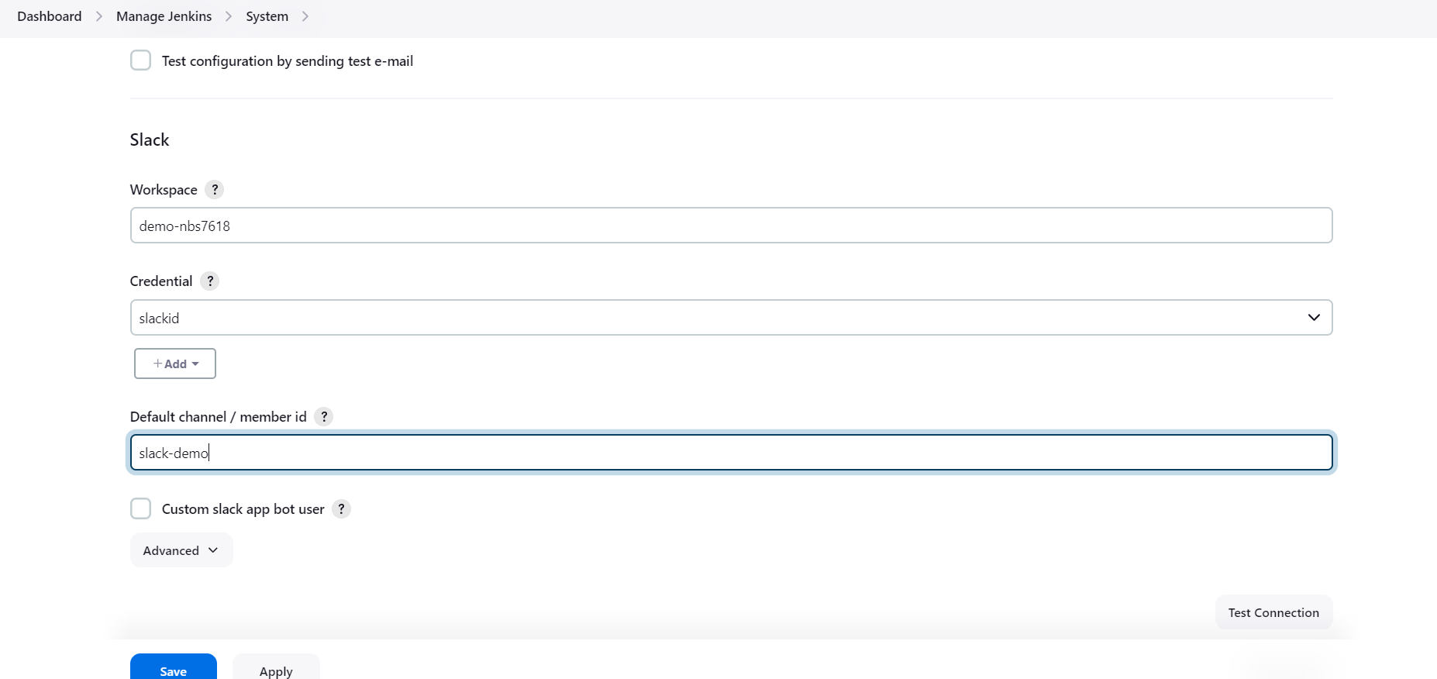

Save the changes

Also go to ManageJenkins 🡪 security 🡪 Select -> Allow anonymous read access

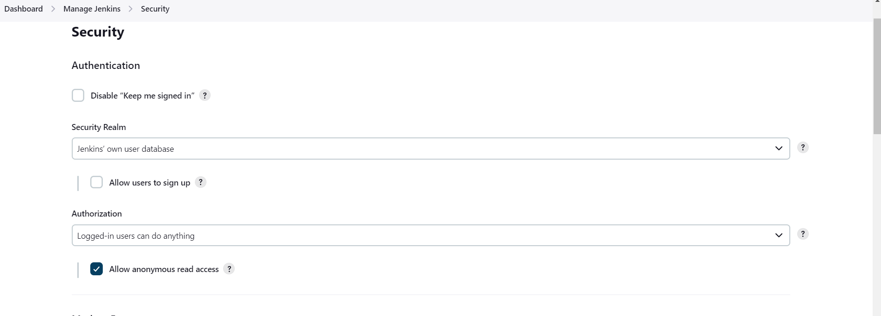

Save the changes

Setup complete.

Demo : Create job that will send notification to Slack channel

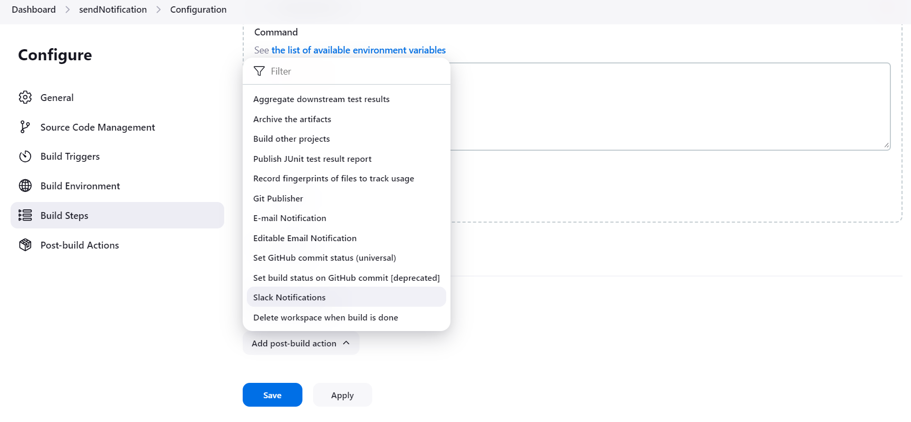

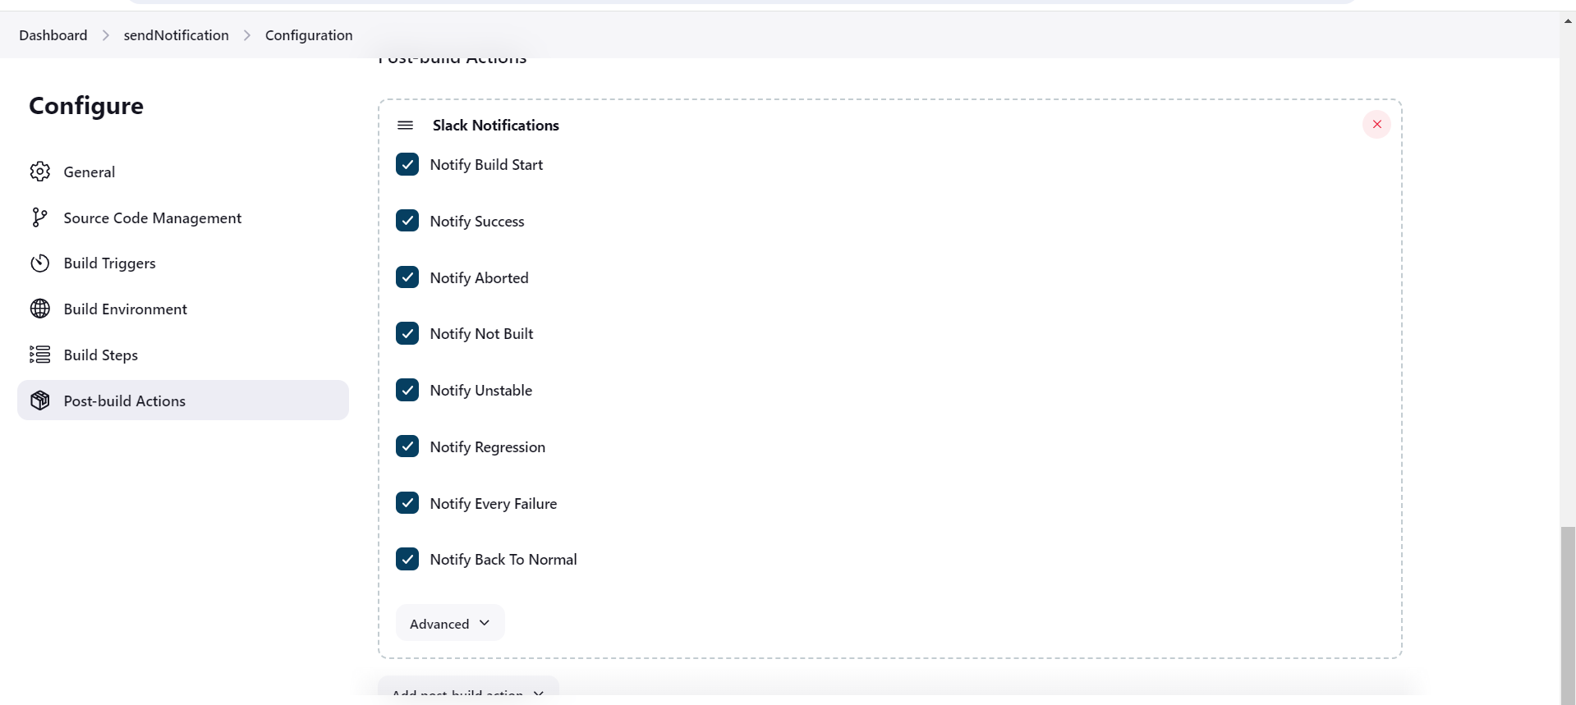

Save the job and build

You will see notifications on slack

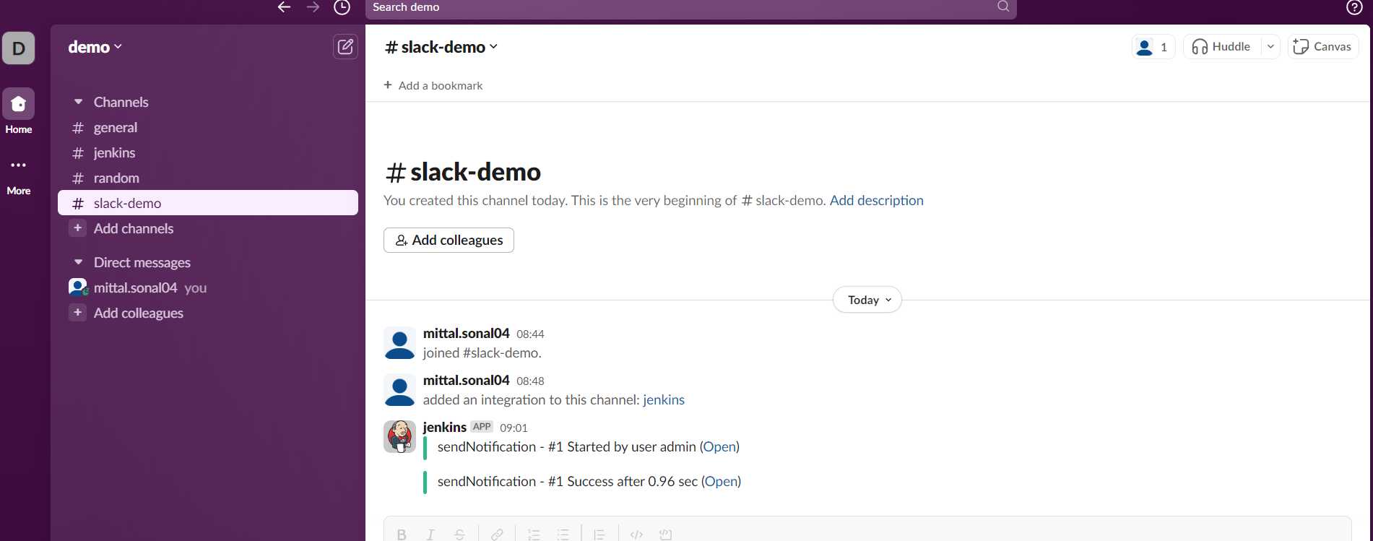

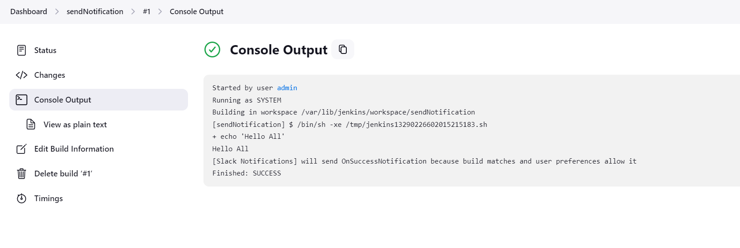

Demo 2: Notify Slack to build a Jenkins Job.

Set a trigger on Jenkins Job -> Build Jobs remotely

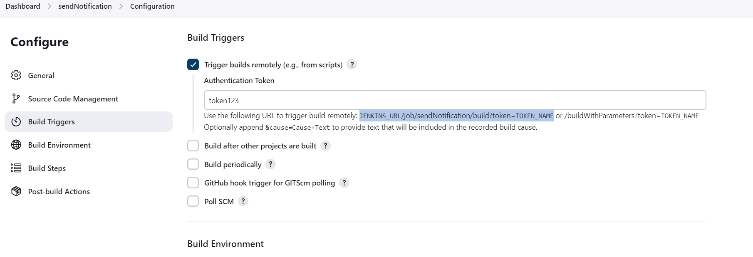

Copy the URL to which we can build remotely as shown above

JENKINS_URL/ job/sendNotification/build?token=TOKEN_NAME

Replace with jenkisn URL and token number

http://3.91.62.239:8080/ job/sendNotification/build?token=token123

Go to slack to set up slash commands app on the channel

Channel name 🡪 click on arraow🡪 select integrations 🡪 add an app

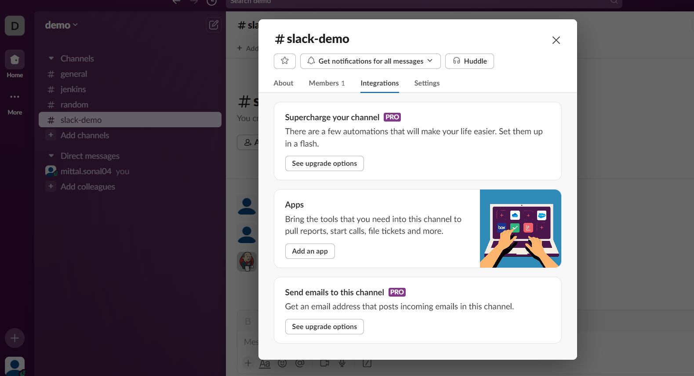

Search for slash commands and click on install

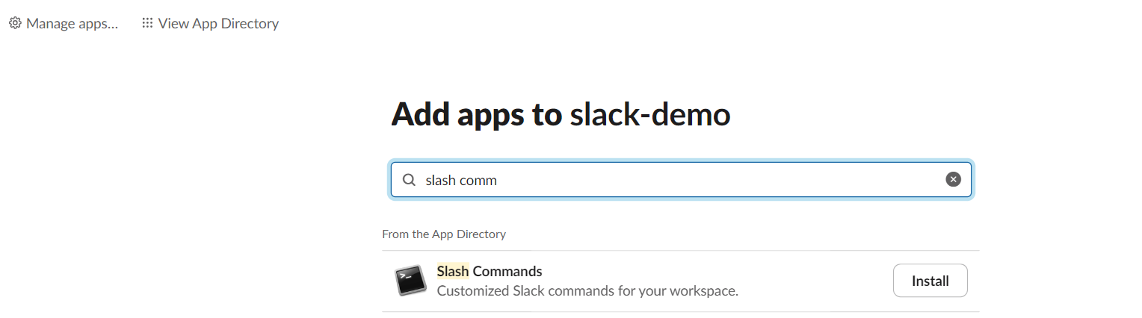

Click on add to slack button

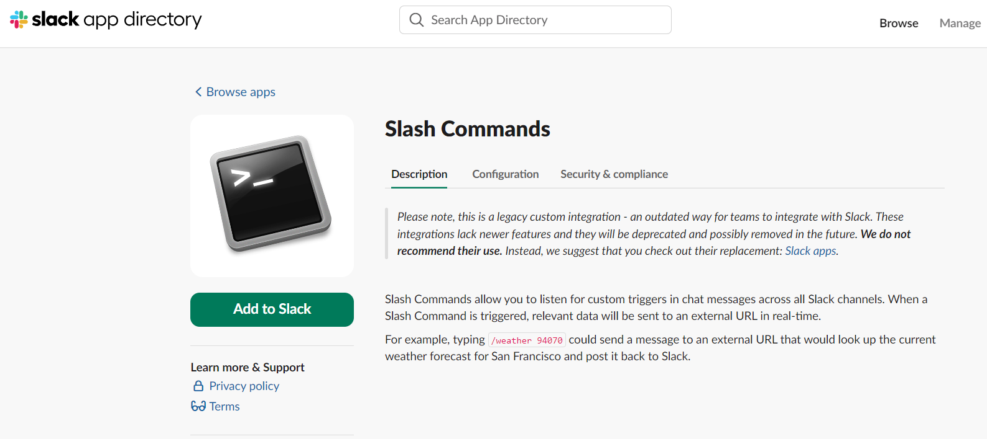

Enter a new command in choose command field 🡪 it has to start with /

Give any name but no space in the command name

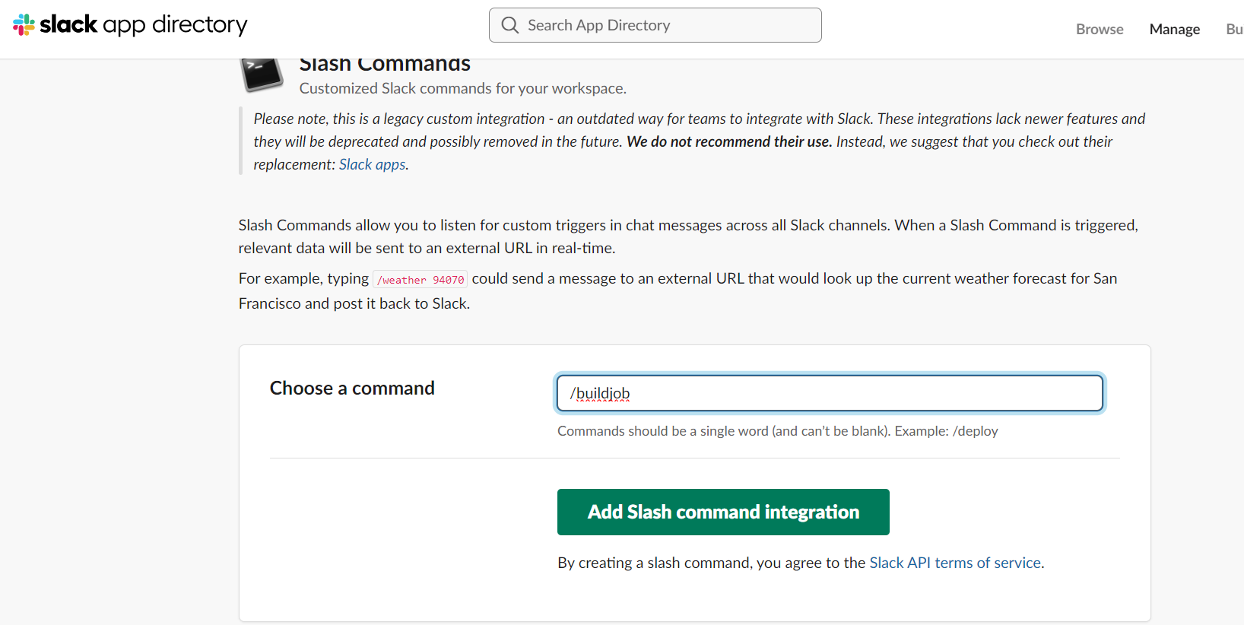

Click on add slash command integration

Scroll down to integrations settings

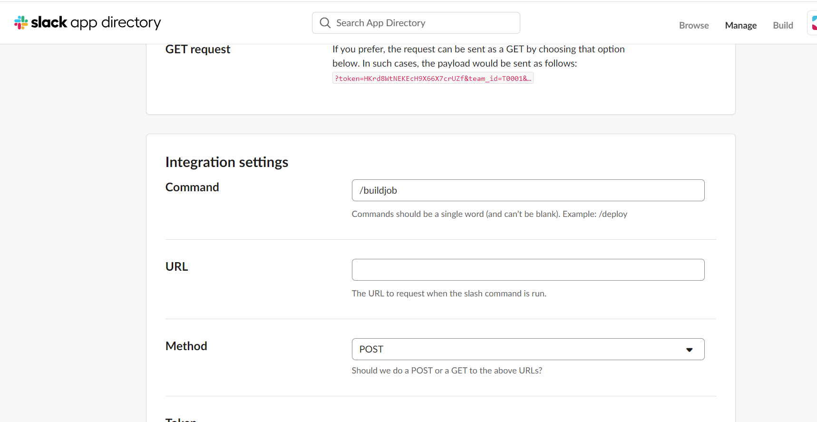

Add the Jenkisn URL that we created above in URL field

http://3.91.62.239:8080/job/sendNotification/build?token=token123

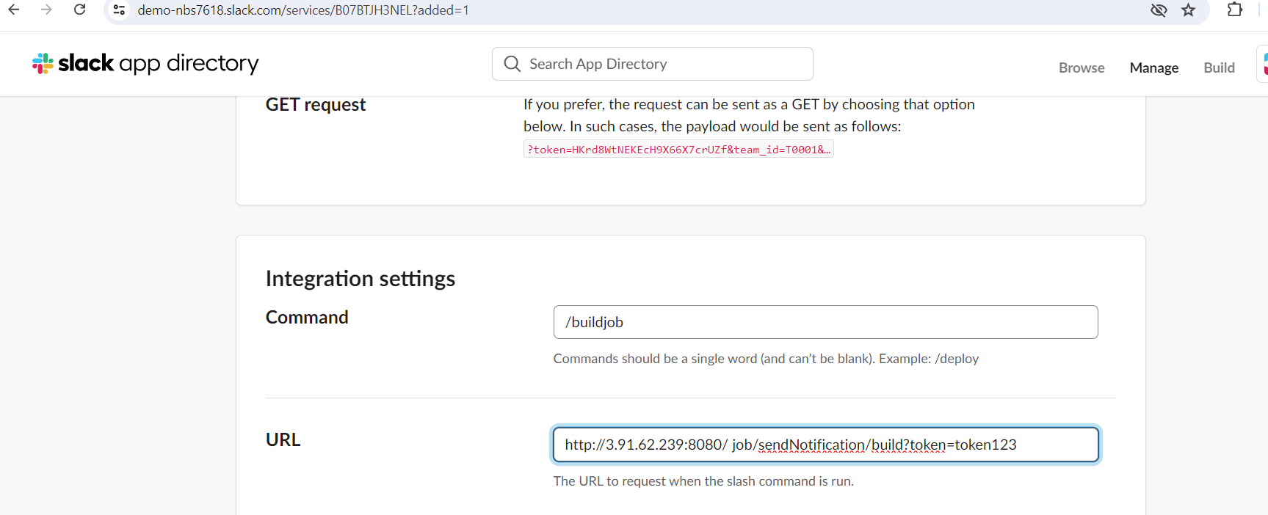

Select method as GET

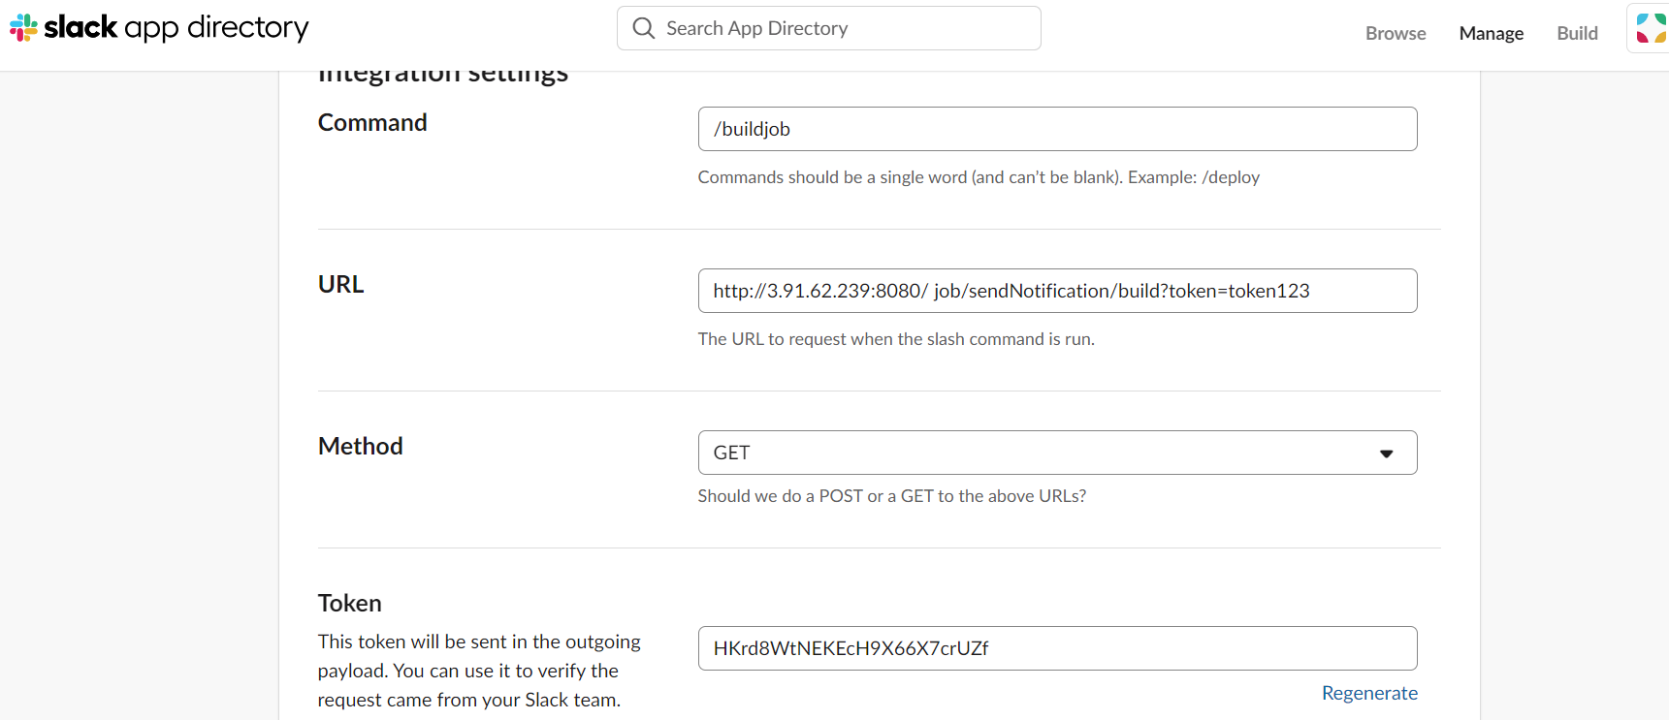

Scroll down and select the check box as show below

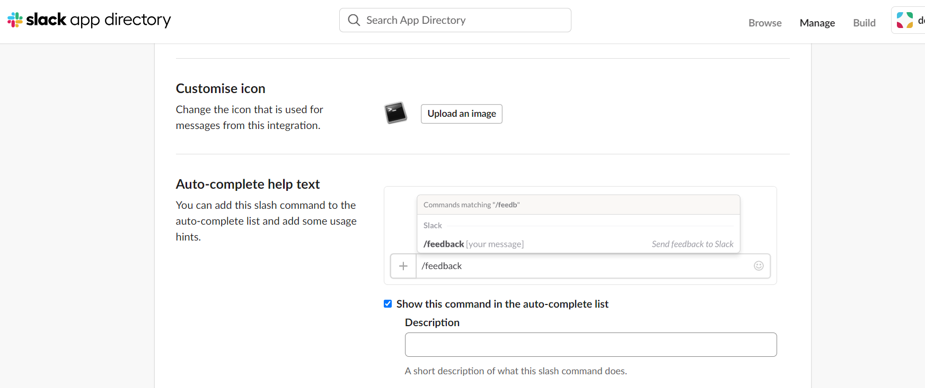

Scroll down and click on save integrations

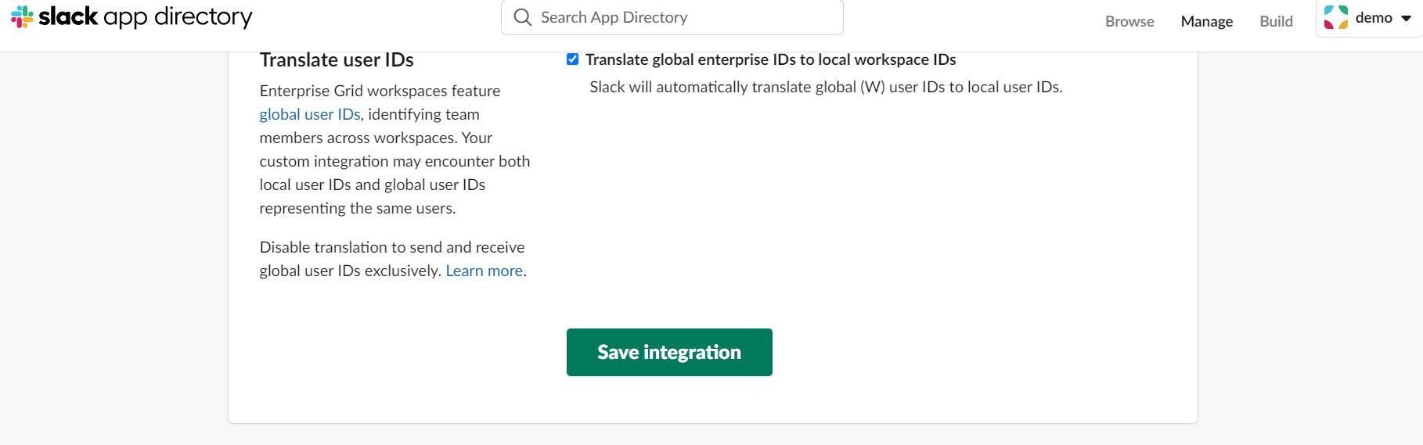

Now go to clack channel page

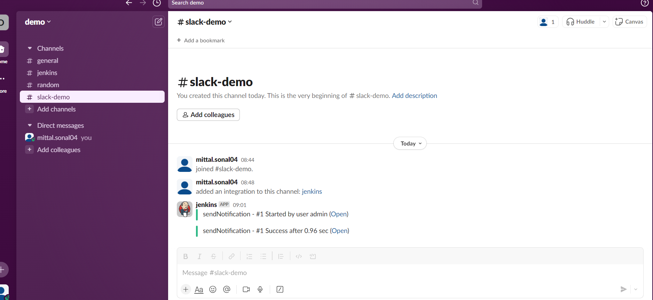

In the message box give the slash command

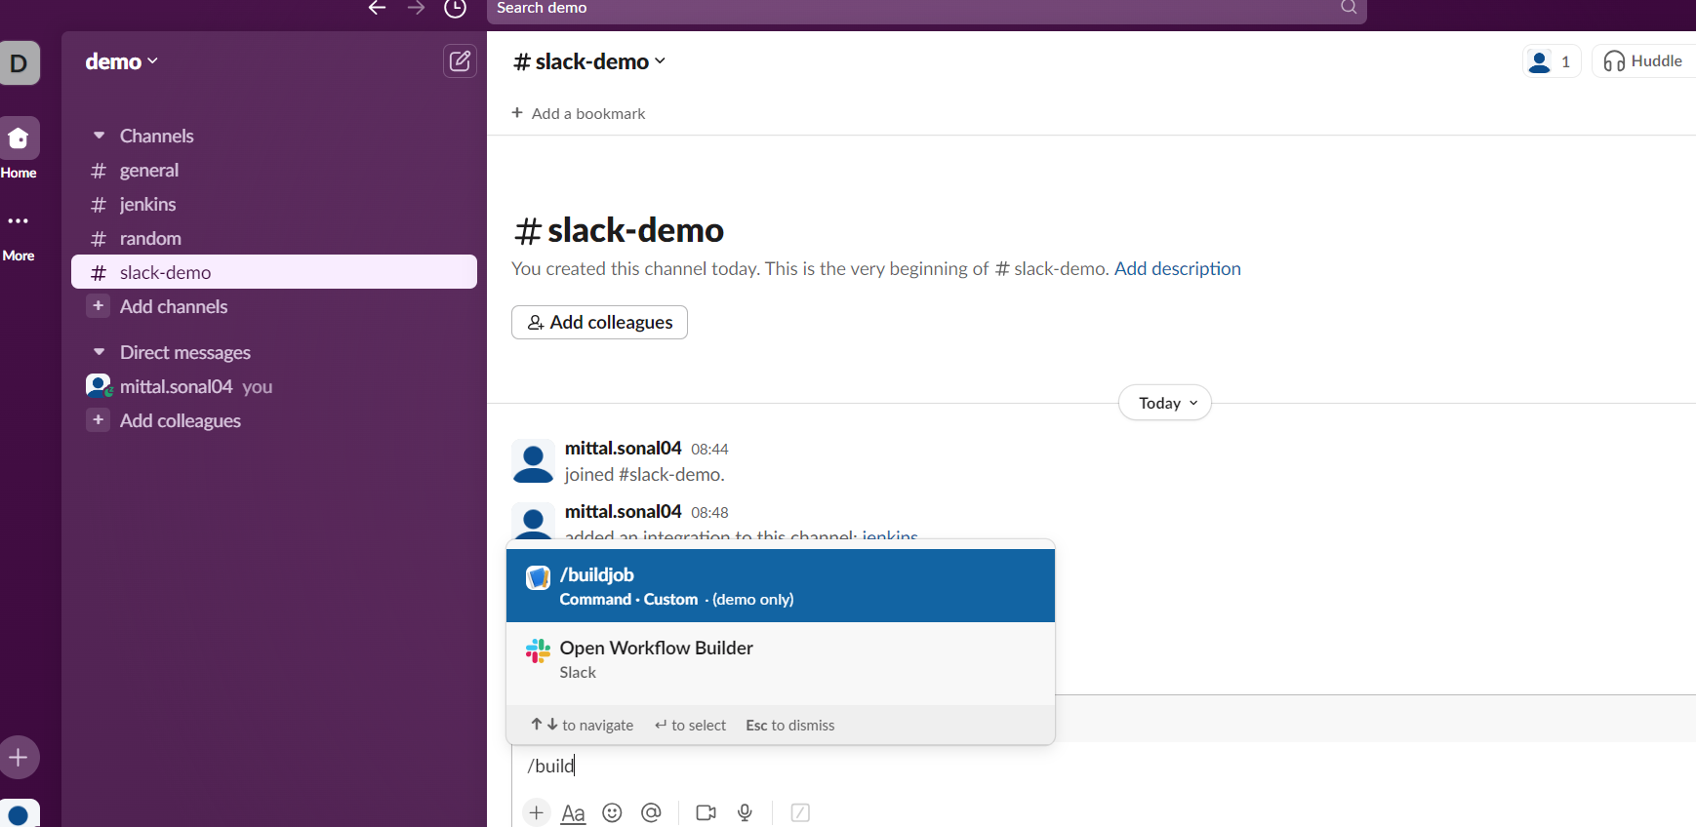

Select and send the notification

